Soil—loose, _________________ material that covers much of Earth’s surface in which _______________ can grow. Soil is composed of broken down rocks, sand, silt and clay.
Permeability—the __________ at which water will flow through ____________
____________ in soil.
- Gravel—small, loose, rounded fragments of rock. There are ___________ spaces between the particles. Therefore, water runs through ___________.
- Sand—feels coarse and grainy and has _____________ grains than gravel. There are large spaces between the grains of sand and it can _______ water and air quickly.
- Silt—feels ___________ and soft. Silt is made up of ____________ grains than sand.
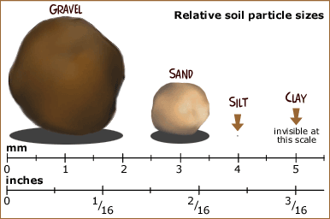
- Clay—feels slick or _____________. Clay is made up of very small grains. There are very __________ spaces between the grains of clay and can hold too much water and not enough air.
Loam—soil that is made up of equal parts of clay, sand, and silt. The best soil for growing plants.

